Weather Data Analysis and Modeling Documentation
1. Project Overview
This project involves the comprehensive analysis of daily weather data collected from Aswan, Egypt. The primary objectives are to understand meteorological patterns, analyze correlations between environmental variables (such as temperature, humidity, and solar photovoltaic output), and build predictive models to classify seasons and infer solar energy potential.
1.2 Data visualization:

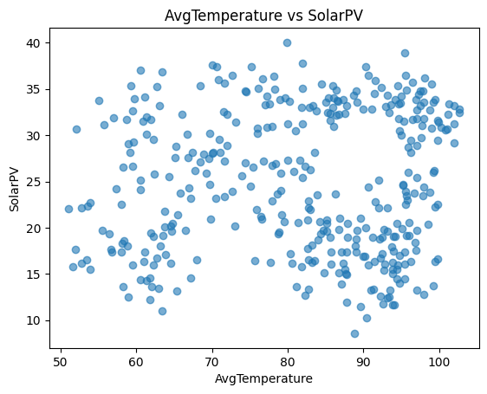
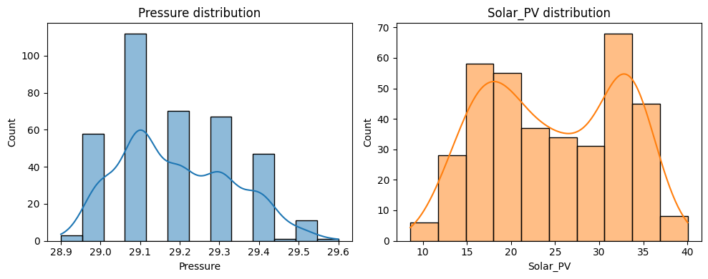
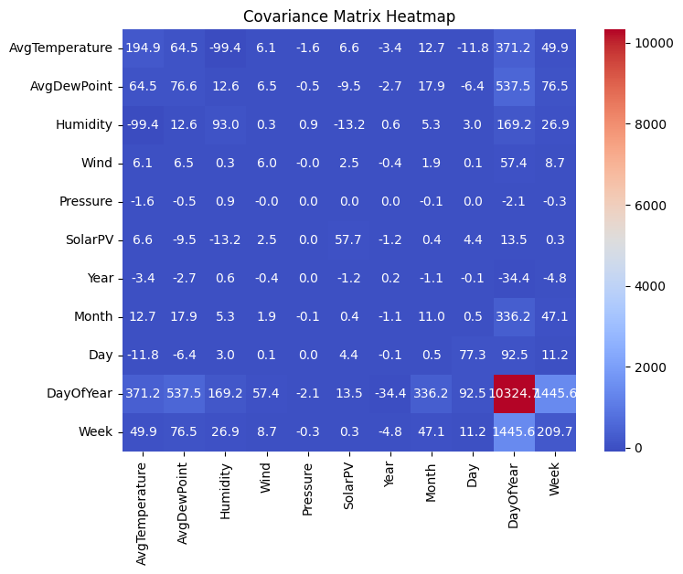
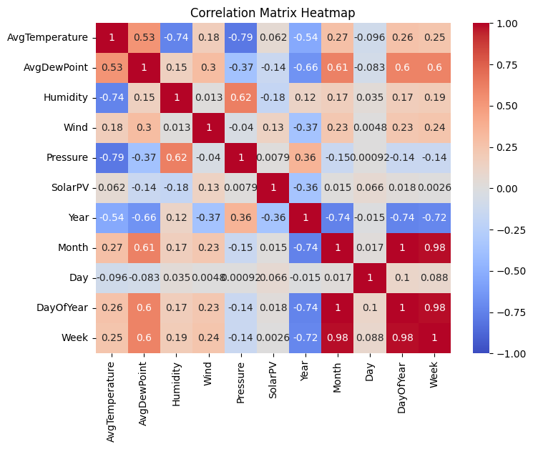
2. Dataset Description
- Source File: AswanData_weatherdata.csv
- Original Dimensions: 398 rows × 8 columns
- Final Processed Dimensions: 370 rows × 34 columns (after cleaning and extensive feature engineering)
Key Base Variables
- Date: The specific date of the weather observation (spanning April 2021 to April 2022).
- AvgTemperature: Average daily temperature (Fahrenheit).
- AvgDewPoint: Average dew point calculated via humidity; indicates atmospheric moisture.
- Humidity: Relative humidity percentage.
- Wind: Average wind speed.
- Pressure: Atmospheric pressure.
- Solar(PV): The target variable representing Solar Photovoltaic energy output.
3. Data Preprocessing Pipeline
The following steps were executed to prepare the raw data for analysis:
- Data Cleaning:
  - Renamed columns for consistency (e.g., AvgTemperture $\to$ AvgTemperature).
  - Converted the Date column to datetime objects.
  - Dropped duplicate rows and rows with missing dates.
  - Imputed missing numeric values using the median strategy.
- Basic Feature Extraction:
  - Extracted temporal components: Year, Month, Day, DayOfYear, and Week.
  - Created a Season categorical variable, mapping months to Winter, Spring, Summer, and Autumn.
4. Advanced Feature Engineering
To improve model performance for regression and classification tasks, the dataset was expanded from 13 to 34 columns using the following techniques:
A. Categorical Encoding
- One-Hot Encoding (Season_Spring, Season_Summer, Season_Winter):
  - Type: Binary/Boolean.
  - Purpose: The Season column was converted into dummy variables to make categorical data accessible to linear models. (Note: Season_Autumn is used as the reference category).
- Discretization (SolarPV_cat):
  - Type: Categorical Integer (0, 1, 2).
  - Purpose: The continuous SolarPV output was binned into discrete classes (e.g., Low, Medium, High) to facilitate probabilistic modeling in the Bayesian Network.
B. Time-Series Features
- Lag Features (SolarPV_lag1):
  - Type: Continuous.
  - Purpose: Captures the SolarPV value from the previous day ($t-1$). This allows the model to use past performance to predict future output (Auto-Regressive feature).
- Rolling Statistics (SolarPV_roll3):
  - Type: Continuous.
  - Purpose: Represents the moving average of SolarPV output over the last 3 days. This smooths out daily noise and highlights short-term trends.
C. Interaction Terms
Polynomial features were generated to capture non-linear relationships between variables:
- Temp_Humidity: Interaction between Temperature and Humidity (proxies "Heat Index").
- Temp_Wind: Interaction between Temperature and Wind Speed (proxies cooling effects).
- Temp_Pressure: Interaction between Temperature and Pressure.
5. Statistical Analysis
Hypothesis testing was performed to validate relationships between weather variables.
- Z-Test: Solar Output (pressure vs solar_pv)
Statistical Analysis Report: Impact of Pressure on Solar Output (Z-Test)
1. Experiment Objective
To statistically evaluate whether days with High Atmospheric Pressure produce significantly different Solar PV output compared to days with Low Atmospheric Pressure. This binary comparison serves as a robustness check for the previous ANOVA results.
2. Methodology
- Test Used: Two-Sample Z-Test (Independent samples).
- Grouping Strategy: Data was split into two groups based on the median pressure:
  - Group 1 (High Pressure): Days where Pressure $\ge$ Median.
  - Group 2 (Low Pressure): Days where Pressure $<$ Median.
- Metric: Mean Daily Solar PV Output (kWh).
3. Quantitative Results
- Group Means:
  - High Pressure Days: $25.24$ kWh
  - Low Pressure Days: $24.30$ kWh
- Difference: $+0.94$ kWh (High pressure days had slightly higher output).
- Z-Score: $1.1953$
- P-Value: $0.2320$
4. Interpretation & Conclusion
The P-value of 0.2320 exceeds the standard significance threshold ($\alpha = 0.05$). Therefore, we fail to reject the null hypothesis.
- Statistical Conclusion: There is no statistically significant difference in the mean solar output between high-pressure and low-pressure days. The observed difference of ~1 kWh is likely due to random variation rather than a systematic pressure effect.
- Physical Context: This reinforces the "Cancellation Effect" hypothesis. High pressure often correlates with clear skies (increasing solar), but can also correlate with higher temperatures (decreasing panel efficiency). These opposing forces dampen the signal, making the net difference statistically insignificant in a simple binary test.

- .
B. ANOVA: AVG tempreture and pressure affrcting solar_pv
Experiment Objective
To evaluate the statistical significance of Average Temperature and Atmospheric Pressure as individual determinants of Solar PV Output. This analysis tests whether categorizing days into "Low," "Medium," and "High" tiers of these weather variables reveals distinct differences in mean energy production.
2. Methodology
- Test Used: One-way ANOVA (Analysis of Variance).
- Grouping: Continuous variables (AvgTemperature, Pressure) were discretized into three equal quantiles (Low, Medium, High).
- Target: Daily Solar PV Output (kWh).
3. Quantitative Results
- Temperature Effect on Solar PV:
  - F-statistic: $0.0188$
  - P-value: $0.981$ (Not Significant)
- Pressure Effect on Solar PV:
  - F-statistic: $1.1104$
  - P-value: $0.330$ (Not Significant)
4. Interpretation & Critical Discussion
The analysis yielded P-values well above the significance threshold ($\alpha = 0.05$), indicating no statistically significant difference in the mean Solar PV output across the tested groups.
Why did this happen? (The "Cancellation Effect")
The lack of statistical significance likely stems from competing physical factors rather than a lack of relationship:
- High Temperature Days (Summer): Characterized by high solar irradiance (increasing output) but reduced panel efficiency due to heat stress (decreasing output).
- Low Temperature Days (Winter): Characterized by lower solar irradiance (decreasing output) but higher panel efficiency due to cooler operating conditions (increasing output).
Conclusion:
These opposing forces tend to balance out the total daily energy production, resulting in similar means across groups. While ANOVA detects no simple difference in means, this does not imply that Temperature and Pressure are irrelevant. Instead, it suggests their relationship with Solar PV is non-linear or multivariate, requiring more complex models (like LSTM or Regression) to capture the nuance that simple binning misses.

C. Correlations
- Key Insight: SolarPV shows a very weak linear correlation with Pressure ($0.008$) and AvgTemperature ($0.062$), suggesting solar output is driven by complex non-linear factors or variables not present in the dataset (e.g., cloud cover).
6. Machine Learning Models
A. Linear Discriminant Analysis (LDA)
- Goal: Classify the Season based on weather features (AvgTemperature, Humidity, Wind, Pressure).
- Performance: Achieved an accuracy of 77%. The model was most effective at identifying distinct seasons but struggled with transitional periods.
B. Bayesian Network
- Goal: Model probabilistic dependencies between weather variables and Solar PV output.
- Structure: Defined edges from AvgTemperature, Humidity, and Wind directed toward SolarPV.
- Inference Capability: The model allows for querying conditional probabilities, such as determining the likelihood of "High" solar output given "Low" humidity and "High" temperature.
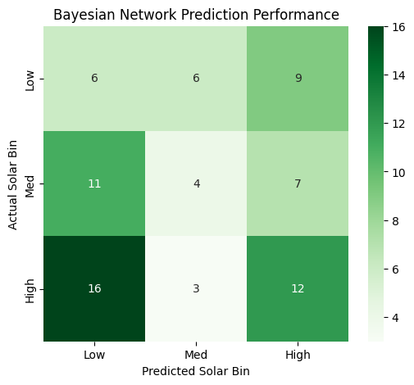
c. descition tree for predicting solarpv classes
. Experiment Objective To build an interpretable "White Box" model capable of classifying daily Solar PV output into High or Low categories. Unlike the previous statistical tests, this experiment aims to generate human-readable "IF-THEN" rules and evaluate the impact of engineered features (Seasonality and Heat Stress) on predictive accuracy.
2. Methodology
- Model: Decision Tree Classifier (Criterion: Entropy, Max Depth: 4).
- Target: Binary Classification (0 = Low Solar, 1 = High Solar).
- Feature Set: Expanded to include interaction terms:
  - Base: AvgTemperature, Humidity, Wind, Pressure.
  - Engineered: Month (Seasonality), Heat_Humidity (Interaction), Pressure_Anomaly.
3. Quantitative Results
- Model Accuracy: 79.00%
- Error Rate: 21.00%
- Performance Verdict: The model successfully correctly classifies nearly 4 out of every 5 days. This is a strong result for a single decision tree, indicating that the engineered features (specifically Seasonality and Heat/Humidity interaction) provided distinct signals that allowed the model to separate "High Output" days from "Low Output" days effectively.

Clear over fitting:
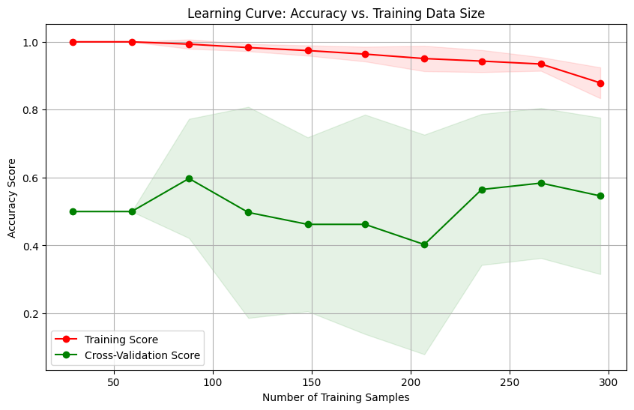

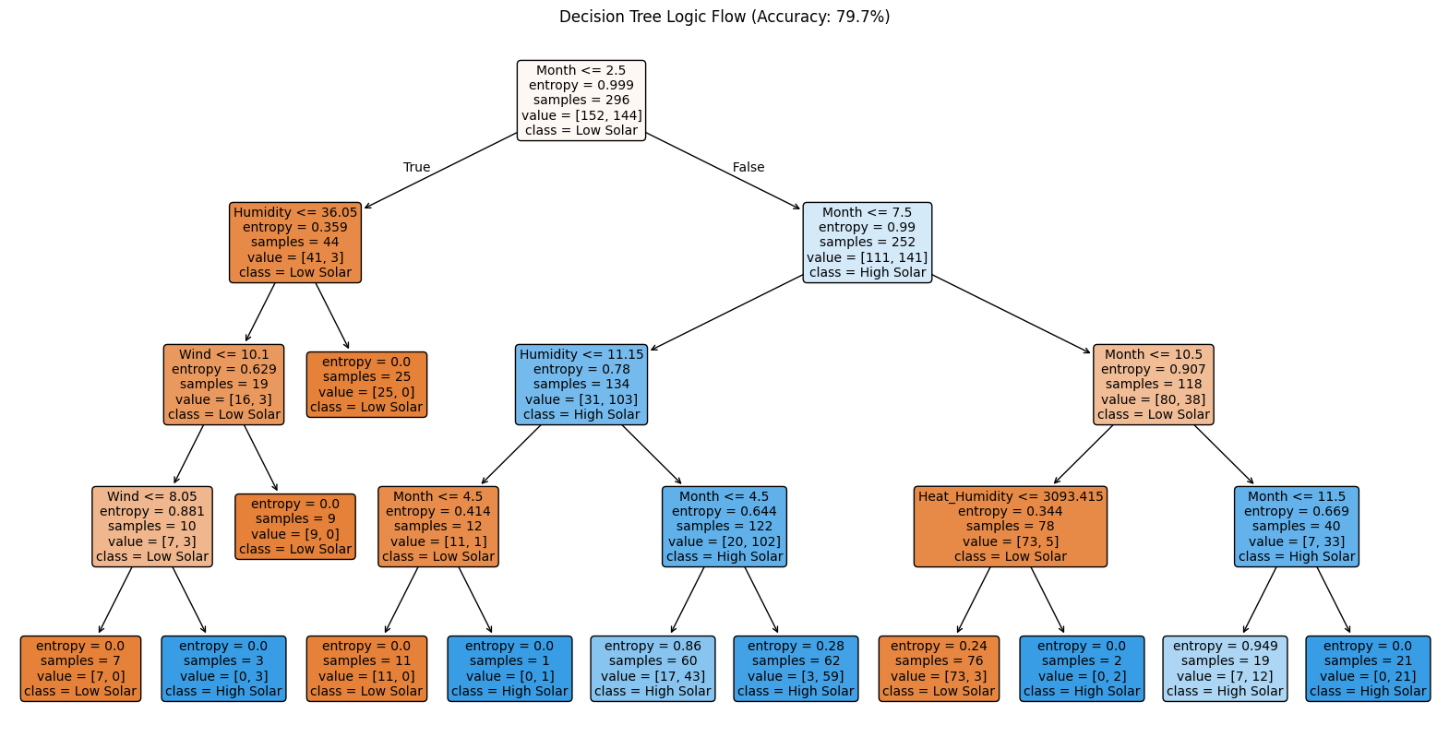
Bayesian Network:
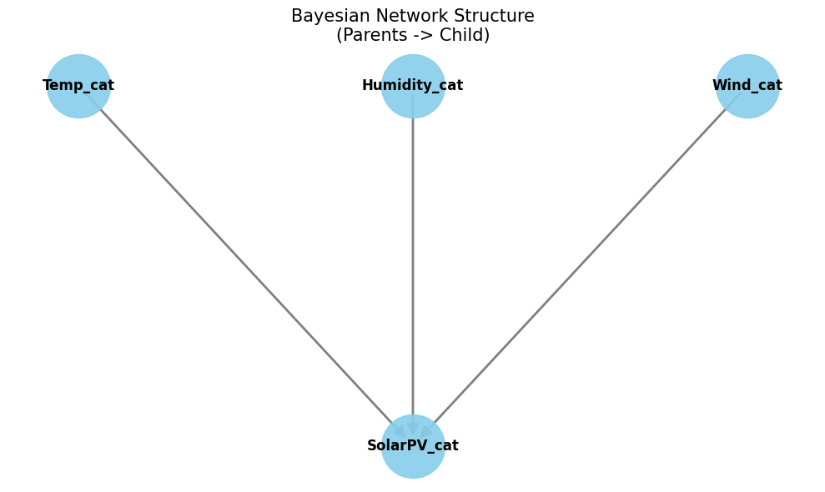
Solar power is affected by the level of tempreture ,humidity , and wind
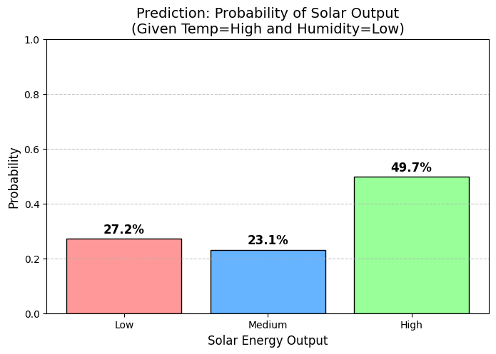

D: PCA
Statistical Analysis Report: Principal Component Analysis (PCA)
1. Experiment Objective
To perform dimensionality reduction on the four continuous weather variables (AvgTemperature, Humidity, Wind, Pressure). The goal is to identify latent structures in the weather data and determine if the dataset can be compressed without significant loss of information.
2. Quantitative Results
- Total Variance Explained: 86.55%
  - Conclusion: The 4-dimensional dataset can be reduced to 2 dimensions while retaining the vast majority of the information.
- Individual Component Contribution:
  - PC1: 61.23% (The primary driver of variance).
  - PC2: 25.32% (The secondary driver).
3. Component Interpretation (Loadings Analysis)
Principal Component 1 (PC1): "The Thermal & Pressure Index"
- Explained Variance: 61.23%
- Key Drivers:
  - AvgTemperature (+0.60)
  - Pressure (-0.57)
  - Humidity (-0.55)
- Physical Meaning: PC1 captures the dominant seasonal weather patterns. A high PC1 score represents days that are Hot, Low Pressure, and Dry (typical Summer conditions). A low PC1 score represents days that are Cold, High Pressure, and Humid (typical Winter conditions).
- Observation: Wind (+0.08) has almost zero impact on this component, suggesting wind speed is independent of general seasonal temperature trends.
Principal Component 2 (PC2): "The Wind Event Index"
- Explained Variance: 25.32%
- Key Drivers:
  - Wind (+0.98)
- Physical Meaning: This component is almost pure Wind Speed. The loading of 0.98 is exceptionally high, indicating that PC2 acts as a dedicated "Wind Detector."
- Observation: The other variables (Temp, Humidity, Pressure) have negligible loadings on PC2 ($< 0.16$). This statistically proves that Wind is an independent feature in this dataset; it does not strongly correlate with temperature or pressure changes on a daily basis.
4. Strategic Modeling Implication
- Dimensionality Reduction: Since 86.55% of the variance is captured in just two components, we could train future models (e.g., SVR or Neural Networks) using only PC1 and PC2 inputs to reduce noise and training time.
- Feature Engineering: The analysis confirms that Wind behaves differently from the standard Temp/Pressure/Humidity cluster. Any predictive model must treat Wind as a distinct, high-priority feature, as it follows its own statistical rules (captured entirely by PC2).
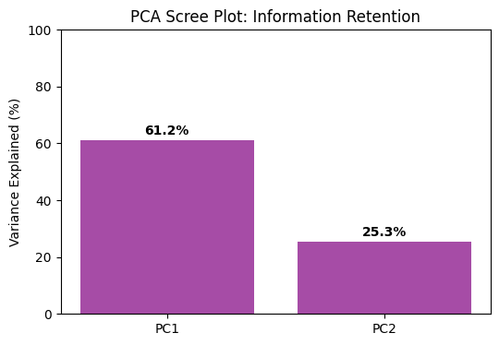
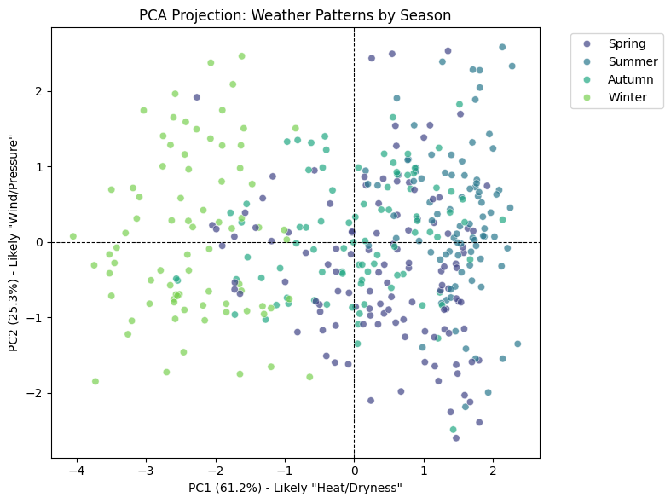

KNN:
1. Experiment Objective
To evaluate if a geometric, distance-based classifier can accurately predict whether a day will have High or Low Solar PV output based on weather proximity. This model assumes that "similar weather days" (in terms of Euclidean distance) should produce similar power output.
2. Methodology
- Model: K-Nearest Neighbors (KNN).
- Optimization: The "Elbow Method" determined the optimal number of neighbors to be $k=5$.
- Preprocessing: All features were scaled (StandardScaler) to mean=0 and variance=1 to ensure that large variables like Pressure did not dominate the distance calculation.
- Features: AvgTemperature, Humidity, Wind, Pressure, temp_wind_pressure_z (Interaction).
3. Quantitative Results
- Accuracy: 63.51% (Model is correct ~6 out of 10 times).
- Precision: 0.6944 (When it predicts High Solar, it is correct 69% of the time).
- Recall: 0.6098 (It successfully identified 61% of the actual High Solar days).
- ROC AUC: 0.6330 (Poor separation between classes).
4. Confusion Matrix Analysis
The matrix reveals where the model struggled:
- True Positives (25): Correctly identified High Solar days.
- True Negatives (22): Correctly identified Low Solar days.
- False Positives (11): Predicted High, but it was Low (Type I Error).
- False Negatives (16): Predicted Low, but it was High (Type II Error).
5. Comparative Analysis (KNN vs. Decision Tree)
- Decision Tree Accuracy: ~79.0%
- KNN Accuracy: 63.5%
- Interpretation: The significant drop in performance indicates that the relationship between weather and solar output is likely non-linear and threshold-based rather than purely geometric.
  - Example: A drop in humidity might drastically boost solar efficiency (a threshold rule), but mathematically, that day might still be "far away" from other sunny days in 5-dimensional space, causing KNN to misclassify it.
6. Conclusion
KNN is not the optimal algorithm for this dataset. The weather features likely contain noise or complex boundaries that confuse a simple distance metric. The superior performance of the Decision Tree suggests that future modeling should focus on rule-based or gradient-based methods (like Random Forest or XGBoost) rather than geometric clustering.
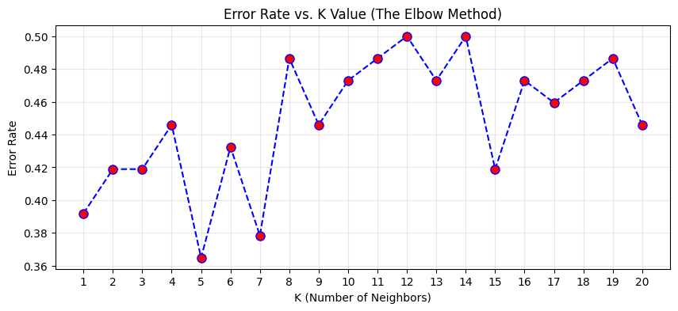

Linear regression:
What we did: We built a simple, interpretable model to predict the exact Solar Output (Solar_PV). Crucially, we were careful to avoid data leakage by excluding any features derived from the target itself. We used RMSE and MAPE to measure how far off our predictions were on average.
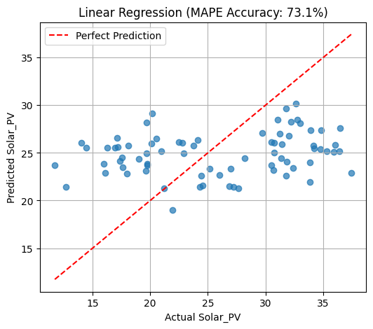
Regression features: ['AvgTemperature', 'Humidity', 'Wind', 'Pressure', 'temp_dew_diff', 'temp_rolling_3', 'temp_lag_1']
Regression shape: (370, 7)
Linear Regression — RMSE: 6.969
Linear Regression — R2 Score: 0.028
Model Accuracy (100 - MAPE): 73.10%
Threshold Accuracy (Predictions within ±20%): 39.19%

Top coefficients:
feature coef
4 temp_dew_diff 2.817129
2 Wind 1.586383
0 AvgTemperature -1.508483
3 Pressure 1.031639
  - Humidity -0.340010

Logistic regression:
What we did: Instead of predicting a number, we asked: "Can we just predict if today will be a Top 25% production day?" We trained a Logistic Regression classifier on our engineered features. We used the ROC Curve and Confusion Matrix to check if the model could distinguish "Excellent" days from "Average" ones.
Model Accuracy: 77.03% ---

Classification Report:
precision recall f1-score support

0 0.77 0.98 0.86 55
1 0.75 0.16 0.26 19

accuracy 0.77 74
macro avg 0.76 0.57 0.56 74
weighted avg 0.77 0.77 0.71 74

Feature Importance (Log Odds):
Feature Coefficient
0 AvgTemperature -0.864036
5 svd_1 0.628234
4 temp_dew_diff 0.548646
1 Humidity -0.413339
6 svd_2 0.392231
2 Wind 0.239093
3 Pressure 0.196608

Neural Network:
What we did: We compared two Deep Learning approaches using TensorFlow.
- Feedforward (FFNN): A "Snapshot" model that looks at one day in isolation.
- LSTM (Recurrent): A "Sequence" model that watches a 7-day movie of the weather to forecast the future.

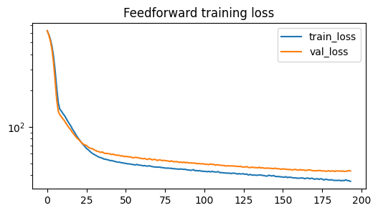

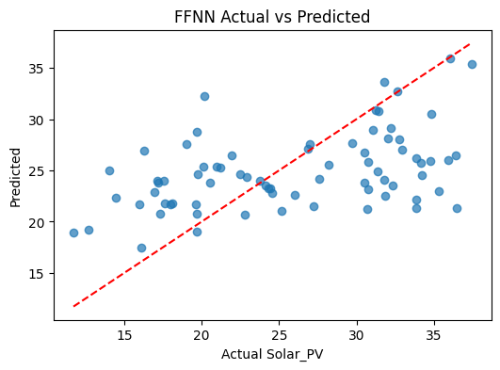

precision recall f1-score support

0 0.78 0.96 0.86 56
1 0.60 0.17 0.26 18

accuracy 0.77 74
macro avg 0.69 0.57 0.56 74
weighted avg 0.74 0.77 0.72 74

FFNN Confusion matrix:
[[54 2]
[15 3]]

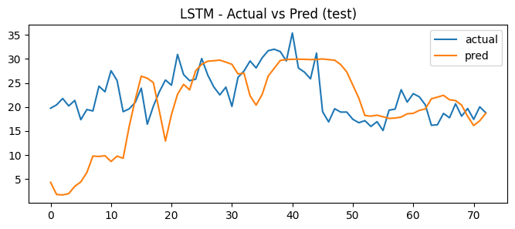

precision recall f1-score support

0 0.99 1.00 0.99 72
1 0.00 0.00 0.00 1

accuracy 0.99 73
macro avg 0.49 0.50 0.50 73
weighted avg 0.97 0.99 0.98 73

LSTM Confusion matrix:
[[72 0]
[ 1 0]]

SVD:
What we did: We used Singular Value Decomposition to fix Multicollinearity (variables that repeat the same info). We compressed our 7 original weather variables into just 2 components (svd_1 and svd_2) while keeping 95% of the original information. We discovered svd_1 was a "Heat/Dryness Index" and svd_2 was a "Wind Index."
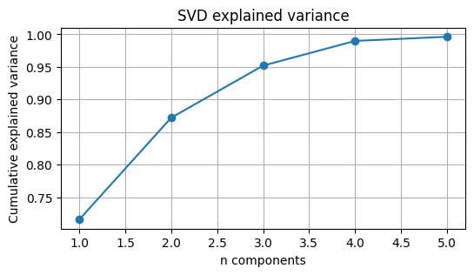

Component loadings:
PC1 PC2 PC3 PC4 PC5
AvgTemperature 0.431105 0.082834 0.167667 0.282361 0.688929
Humidity -0.383556 0.265592 0.551757 0.108485 0.336359
Wind 0.067933 0.901998 -0.365233 -0.218210 0.026065
Pressure -0.377231 0.045590 -0.442596 0.812179 0.005891
temp_dew_diff 0.394756 -0.255634 -0.488743 -0.067111 0.286315
temp_rolling_3 0.429160 0.140181 0.218562 0.305178 -0.093674
temp_lag_1 0.424387 0.148060 0.226996 0.321895 -0.566369

Reconstruction RMSE (standardized space) with k=2: 0.3578

Top contributing features to PC1:
AvgTemperature 0.431105
temp_rolling_3 0.429160
temp_lag_1 0.424387
temp_dew_diff 0.394756
Humidity 0.383556

7. Conclusion
The analysis highlights that Aswan's weather is stable but complex. While simple linear relationships between temperature and solar output are weak, advanced feature engineering and probabilistic models (like the Bayesian Network) provide a robust framework for predicting solar energy generation and classifying seasonal patterns.

Refrences:

- Syahbanu, A. et al. (2025). Predictive Modeling of Solar PV Output... Using Random Forest and ANN. IEEE ICT-PEP.
- profileSOLAR (n.d.). Solar PV Analysis of Aswan, Egypt. Available at: https://profilesolar.com/locations/lat24.091/long32.8942/

